**Faculdade de** **Engenharia** **da**​  **Universidade** **do** **Porto**​

​ ​ 

​ **Sistemas de Informação e Base de Dados**

# MIEEC

# **Project Report**

COVID-19 Management System

Guilherme Knorst Magnago​ ​ up201902438@​letras.up.**pt**

**J**oão Daniel Ferreira Peixoto​ ​ ​up201707426@​ fe.up.pt​

# Topic description:

In a hypothetical circumstance, the University of Porto intends to implement a tracking system designed to identify possible COVID-19 infection chains between students, professors, and other staff workers. The system consists in tracking every member of the community who has attended each class in person and isolate everyone who recently encountered a sick person.

        • The system works across the entire University, being separated by different faculties such as the faculty of engineering or the faculty of arts and humanities.

        • Every person that studies or works on the college is stored in the database. Their home address is also stored so that it is possible to control possible specific outbreak locations.

        • Every student has a unique student number (ID), a name, an institutional e-mail, tax identity number and a phone number. Each student is enrolled or not in a certain number of courses during each semester. They are also enrolled in a specific class of each of the courses they attend to in that semester. Each student is also associated to one degree (e.g. a major, master or doctorate program, which is itself also associated to one faculty of the University).

        • Every professor in the university also has a unique ID number, a name, an institutional e-mail, and a possible classification (in case they work as researchers as well). Professors can also enroll in courses as students, in which case they use that same ID number. A professor that also acts as a student is possibly associated to two different faculties (one as a student, one as a professor).

        • Each classroom has a designated janitor as the cleaning responsible for it. Each janitor has an ID number, a name, and a phone number.

        • It is important to keep track of which course each student attends. Each course has at least one professor associated to it.

        • Each course can have different classes taken in different schedules and can be taught by different professors or by the same one.

        • Each class of each course has a list of students enrolled to it and a recurrence (the days and times it happens). For every occurrence of a class, a list of people who attended in person is to be generated (through the reading of the student/staff card) to keep track of who has been in contact with whom.

        • To be computed as being present in a class, every person must have swiped their cards within the time period of the class they're attending.

        • Whenever there is a confirmed case of COVID-19 within the community, every person who has attended the same classes as them in the last two weeks is to be contacted and remain in isolation. The janitor responsible for that classroom is to quarantine as well. In this case it is attributed a red warning to these people.

        • If a student receives a red warning (direct contact with a sick person) then every other student in other classes with this same student receives a yellow warning so they can be more careful and attentive to possible symptoms.

        • In case a janitor tests positive, everyone who attended a lesson in any of the classrooms under their responsibility should also receive a yellow warning.

# UML diagram:

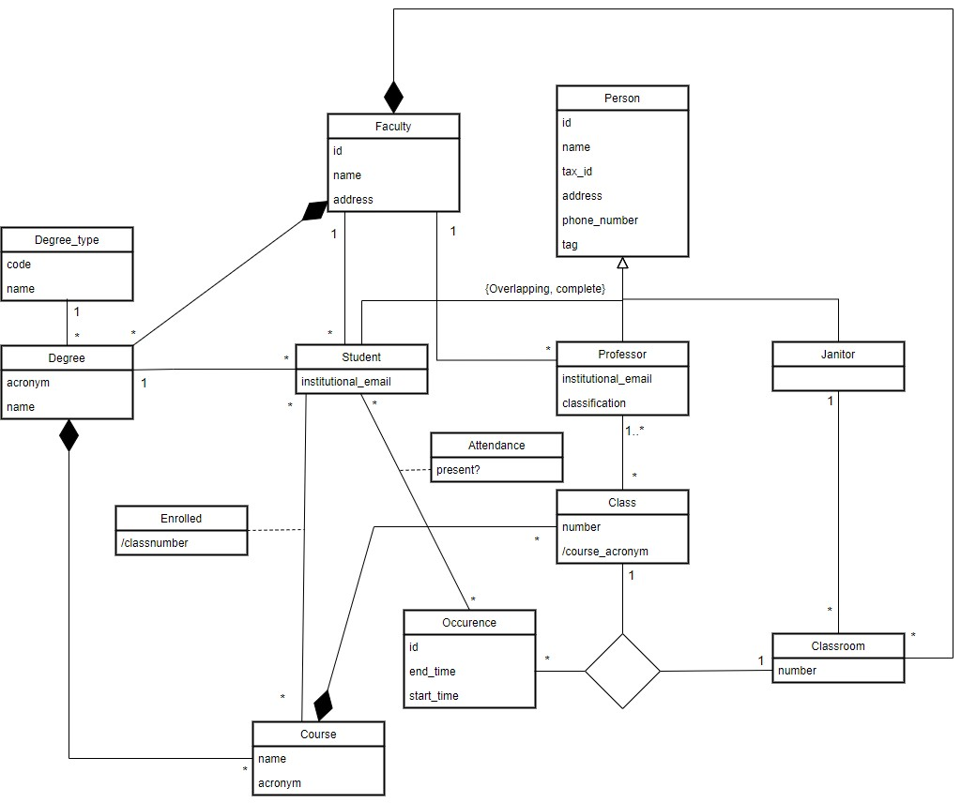

# Relational model:

Person(id, name, tax_id, address, phone_number, tag)

NOT NULL(name)

UNIQUE(tax_id)

Student(id -> Person, institutional_email, degree -> Degree, faculty -> Faculty, course -> Course, occurrence -> Ocurrence)

Professor(id -> Person, institutional_email, classification)

Janitor(id -> Person)

Faculty(id, name, address)

NOT NULL(name, address)

UNIQUE(name)

DegreeType(code, name)

NOT NULL(name)

Degree(acronym, name, faculty -> Faculty)

NOT NULL(name, faculty -> Faculty)

Course(acronym, name, degree -> Degree)

NOT NULL(name, degree -> Degree)

UNIQUE(name)

Enrolled(student -> Student, course -> Course, classnumber)

Class(course_acronym, number, course -> Course)

NOT NULL(number)

UNIQUE(course_acronym + number)

Classroom(number, janitor -> Janitor, faculty -> Faculty)

NOT NULL(faculty -> Faculty)

Occurrence(id, start_time, end_time)

CHECK(end_time > start_time)

ClassClassroomOccurence(course_acronym -> Class, number -> Classroom, id -> Occurrence)

Attendance(student -> Student, occurrence -> Occurrence, present)

Notes:

On super class Person: Tag can be equal to NULL, yellow or red, meaning respectively that the person has not been in contact with anyone sick; has been in indirect contact with a confirmed sick person and has been in direct contact with a confirmed sick person.

On class Class: the number of a class can be repetead, but the number + course_acronym combination is UNIQUE (eg: SIBD01).